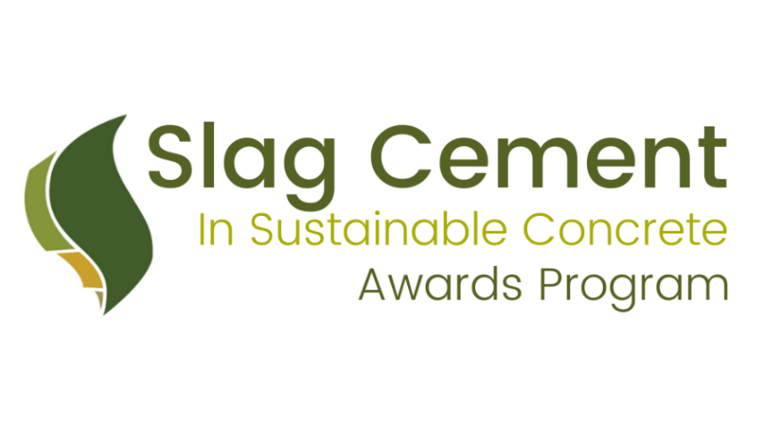

2024 Michael Thomas Research Award Nomination

Since 2010, the Slag Cement Association (SCA) has been recognizing outstanding projects throughout the United States and Canada that utilize slag cement in an innovative way. In addition, since 2020, SCA has recognized several individuals at their annual awards program who have conducted important and useful research utilizing slag cement. The Michael Thomas Research Award is based on the following criteria:

Qualifications:
- Research projects in the USA or Canada completed or scheduled to be completed between January 1, 2023 and October 1, 2024
- Research projects must be conducted by a U.S. or Canadian University or College and must include the use of slag cement (Ground Granulated Blast Furnace Slag) in the research.
- The researcher, if they are chosen by the SCA Technical Marketing Committee, must be able to present their project in-person during the 2024 Slag Cement in Sustainable Concrete Awards.

Instructions:
- Candidates must fill out the entire Application Form provided below.
- In addition to the Application Form, an overview/paper between 2-4 pages discussing your research project, and findings must be submitted. Review criteria can be found below.
- The more complete your application is, the easier it will be for judges to evaluate the merits of your project. The judging panel—the SCA Technical and Marketing Committee—will not perform additional research on any project beyond what is presented on this form and attachments. In addition to completing the Application Form below, submitting relevant supporting information is encouraged and may include the following: detailed project descriptions, photos (as prints or in high- resolution digital format, 300 dpi .jpg or .tif), videos, testimonials, from project team members, project reports/test data, articles, past awards—anything that will help.
- Return the completed Application Form, overview and supporting information to Nick Brimley, SCA Marketing Director:
  - email: nick.brimley@slagcement.org
  - mail: Nick Brimley
Slag Cement Association 38800 Country Club Drive Farmington Hills MI 48331
- Deadline: entry forms must be received by SCA no later than November 30th, 2024.
- Research projects chosen to be recognized at the Slag Cement in Sustainable Concrete Awards during the Spring 2025 ACI Concrete Convention will receive the $1,000 stipend toward travel expenses and will be selected by January 2025.
- The Slag Cement in Sustainable Concrete Awards is tentatively scheduled for the morning of Wednesday, April 2nd, 2025. Individuals chosen to be recognized for their research projects utilizing slag cement, will be given the opportunity to provide a short PowerPoint presentation on their work.

Review Criteria for Paper:
Papers will be reviewed by the SCA Technical Marketing Committee for their contribution to slag cement research and use. Specific criteria and information we’re looking for include:
- Problem: Importance of the research question
- Ideas: Theoretical base and conceptual contribution
- Approach: Adequacy and sensitivity of research design and methods
- Findings: Contribution to existing knowledge
- Presentation of data: Clear presentation of data linked to the research objectives and research problem
- Organization: Logical organization of the paper
- Contribution to the slag cement industry
- Contribution to concrete industry

Publication and Copyright Release: Project descriptions, photographs, and any other materials submitted with the Awards Form may be used by SCA for press releases, social media, publications, and posting on the SCA website. By submitting the materials for your project, you are providing permission to SCA to use the information, including copyrighted material, without restriction and on a royalty-free basis.

APPLICATION FORM

General Project Information

Project Name:

University:

Professor Name:

Student Name(s):

Address/Location:

City: State: Postal Code:
Project completion or scheduled completion date:
Project Work Duration:
Brief Project Overview (200 words max):

Attached Documents

You are encouraged to submit videos, testimonials, links to relevant articles on the project, photos and any other supporting material that will help the SCA better understand your project and its significance.

Photos/Slides Reports Testimonials Other (specify):

Submitted by
Name: Date: Company: Address: Email: Phone:

