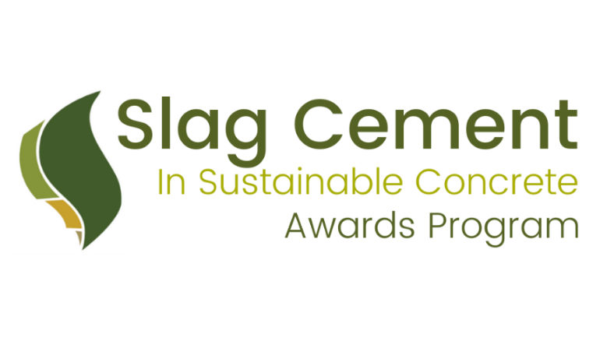
2024 Slag Cement in Sustainable Concrete Awards Program
Nomination Form
(Projects in the USA completed or scheduled to be completed between January 1, 2023 and December 31, 2024)
An overview of the winners from our previous programs can be found on the SCA website.
Publication and Copyright Release: Project descriptions, photographs, and any other materials submitted with the Awards Form may be used by SCA for press releases, social media, publications, and posting on the SCA website. By submitting the materials for your project, you are providing permission to SCA to use the information, including copyrighted material, without restriction and on a royalty-free basis.
Please be as descriptive of your projects as possible. The content in these applications helps SCA create case studies for the SCA website and the promotion of your projects. If possible, please type out your submission, handwritten applications are difficult to decipher.
For detailed instructions and deadline, please see page 5.
General Project Information
Project Name:
Project Address/Location:
City:
State:
Postal Code:
Project completion or scheduled completion date:
Construction Work Duration:
Project Size (Dimensions, Area, Span):

Award Category (check all that may apply by placing an “X” in the box to the left of each category):
 | CATEGORY | DESCRIPTION
 | Architectural | This award recognizes projects that used slag cement in the design to construct an efficient and aesthetically pleasing concrete structure.
 | Durability | This award recognizes projects that used slag cement in concrete structures designed to resist various conditions in its environment.
 | Infrastructure | This award recognizes projects that used slag cement in the construction of infrastructure projects including but not limited to pavements, highways, transit projects, bridges, dams, mining, airports, etc.
 | High Performance | This award recognizes projects that used slag cement to enhance the concrete properties.
 | Innovative Applications | This award recognizes projects that used slag cement in the solution to address challenging jobsite conditions.
 | Lower Carbon Concrete | This award recognizes projects that incorporated slag cement into concrete mixtures designed to reduce environmental impacts, and projects using renewable energy and have reduced waste during construction.

Project Type (check all that may apply by placing an “X” in the box to the left of each category):
Low-Rise Building (up to 3 stories)
Mid-Rise Buildings (4-15 stories)
High-Rise Buildings (15+ stories)
Infrastructure
Decorative Concrete
Repair and Restoration
Soil Stabilization
Portland Limestone Cement Used
Other:

Project Details
- Describe your project in 200 words or less, including pertinent information about size, function, end user or owner, and unique attributes.

- How and why was slag cement used in the project? Provide relevant information such as: type of application (e.g. mass concrete, self-consolidating concrete, soil stabilization, and waste treatment), mix information/proportions, specification requirements, and performance needs (e.g. workability, early/late age strength, durability, appearance).

- How did slag cement contribute to project success? (E.g. what were project results using slag cement, such as strength, speed, constructability, appearance)

- Describe innovative or notable aspects of the project that may not have to do with the use of slag cement.
To help promote the award-winning projects, the SCA would like to gather as much technical information as possible. Unless you’ve included the following information in your answers above, please provide any additional technical details below:
*copy and paste graph if you would like to showcase multiple mix designs used in the project.
Application Type
% Slag Cement Replacement
% Portland Cement
% Portland Limestone Cement
% Other SCM (if applicable)
Aggregate
Water/cement ratio
7-day strengths
28-day strengths

Project Team
Award winning teams will be honored during the Spring 2025 ACI Concrete Convention in Toronto, Ontario, Canada where team members will be honored for their role in the project. Please note some fields are required (*). Required fields left blank will be disqualified. If there is not a person on the team that fits the category, please write N/A.
Owner:
Company
Contact Name
Address
Phone
Email

Contractor:
Company
Contact Name
Address
Phone
Email

Architect:
Company
Contact Name
Address
Phone
Email

Engineer:
Company
Contact Name
Address
Phone
Email

Concrete:
Company
Contact Name
Address
Phone
Email

Slag Cement:
Company
Contact Name
Address
Phone
Email

Submitted by:
Company*
Contact Name*
Address*
Phone*
Email*

Attached Documents
You are encouraged to submit videos, testimonials, links to relevant articles on the project, photos and any other supporting material that will help the SCA better understand your project and its significance.
High quality photos and videos are very helpful to the promotion of the award winners. Examples of videos created with media gathered from past years nominations can be found here on the SCA website.
Instructions
- Please complete the form as fully as possible. If you are lacking certain information, leave that field blank. If the form does not offer enough space for the details you wish to present, submit an attachment with further supporting information.
- The more complete your application is, the easier it will be for judges to evaluate the merits of your project. The judging panel—the SCA Technical and Marketing Committee—will not perform additional research on any project beyond what is presented on this form and attachments. In addition to completing this form, you may submit additional supporting information, including more detailed project descriptions, photos (as prints or in high- resolution digital format, 300 dpi .jpg or .tif), videos, testimonials, from project team members, project reports/test data, articles, past awards—anything that will help.
- Complete the form to the best of your ability. Clearly label every component, including attachments and images, with the name of your project and your contact information. Return it to SCA Marketing Director, Nick Brimley:
  - email: nick.brimley@slagcement.org
  - mail:
Nick Brimley
Slag Cement Association
38800 Country Club Drive
Farmington Hills MI 48331
(attn: 2024 SCA Project Awards)
- Deadline: entry forms must be received by SCA no later than November 30th, 2024.
- Projects for awards will be selected by January 2025.
- Presentation of the awards is being planned during a session at the Spring 2025 ACI Concrete Convention in Toronto, Ontario, Canada on March 30-April 2, 2025. The session will likely be in the morning of Wednesday, April 2, 2025 but exact venue and dates are yet to be confirmed.

